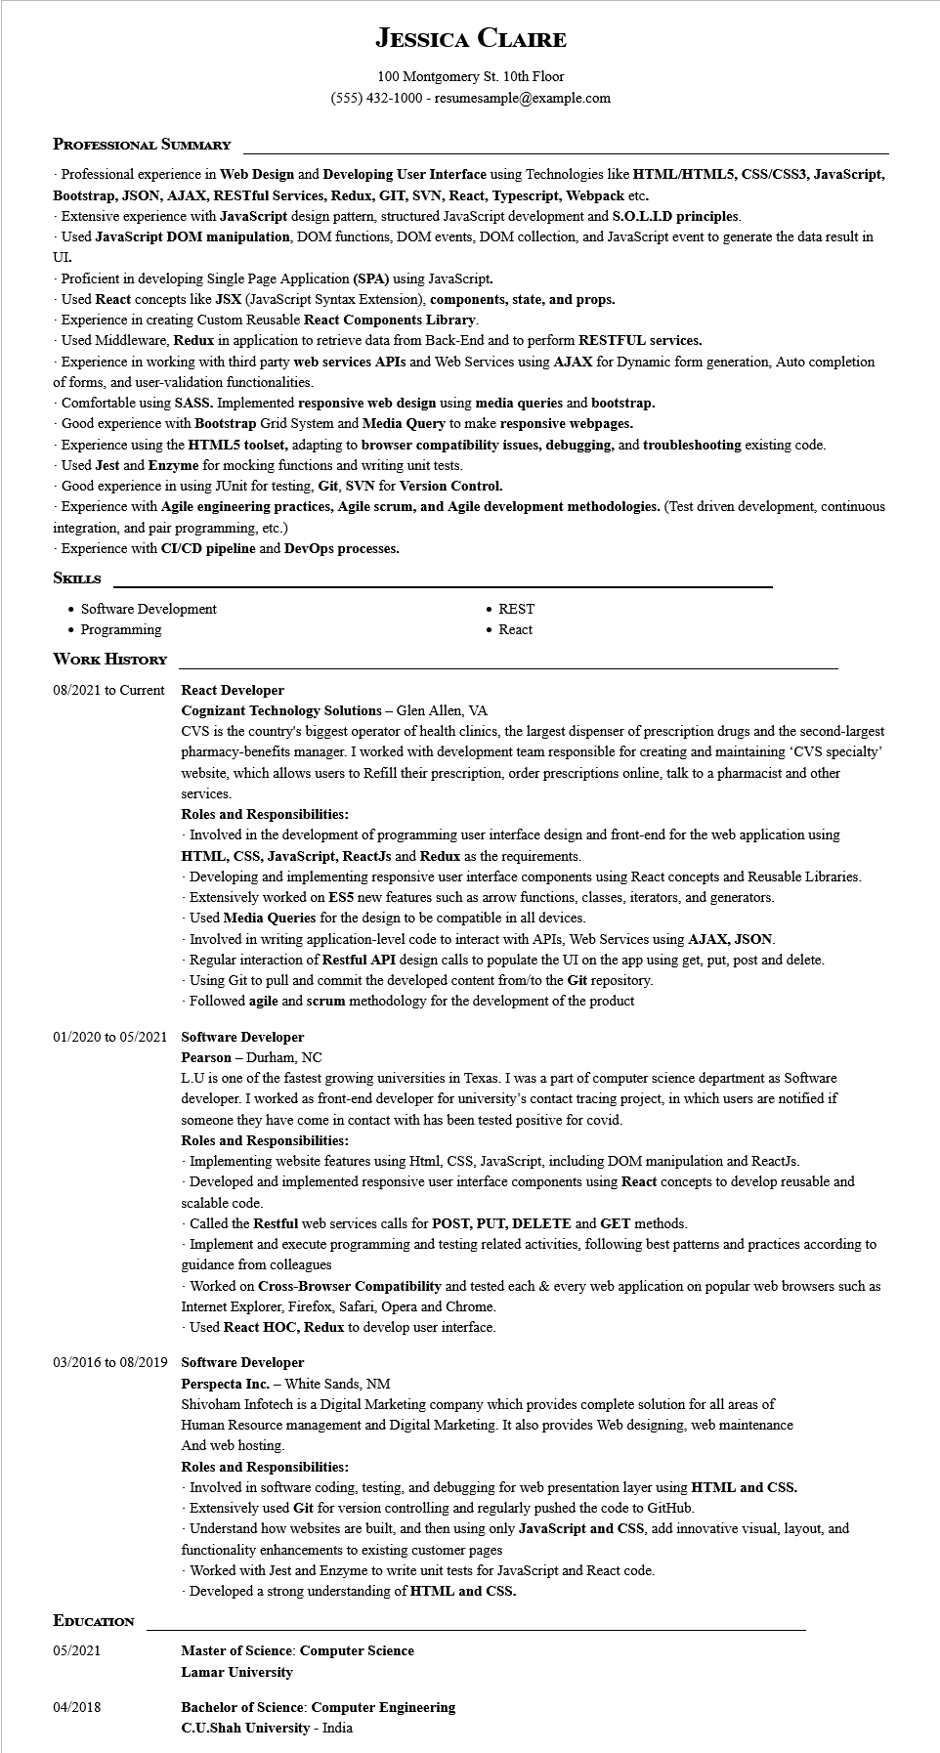
JESSICA CLAIRE
100 Montgomery St. 10th Floor
(555) 432-1000 - resumesample@example.com
PROFESSIONAL SUMMARY
-Professional experience in Web Design and Developing User Interface using Technologies like HTML/HTML5, CSS/CSS3, JavaScript, Bootstrap, JSON, AJAX, RESTful Services, Redux, GIT, SVN, React, Typescript, Webpack etc.
Extensive experience with JavaScript design pattern, structured JavaScript development and S.O.L.I.D principles.
Used JavaScript DOM manipulation, DOM functions, DOM events, DOM collection, and JavaScript event to generate the data result in
UL.
Proficient in developing Single Page Application (SPA) using JavaScript.
Used React concepts like JSX (JavaScript Syntax Extension), components, state, and props.
Experience in creating Custom Reusable React Components Library.
Used Middleware, Redux in application to retrieve data from Back-End and to perform RESTFUL services.
Experience in working with third party web services APIs and Web Services using AJAX for Dynamic form generation, Auto completion of forms, and user-validation functionalities.
Comfortable using SASS. Implemented responsive web design using media queries and bootstrap.
Good experience with Bootstrap Grid System and Media Query to make responsive webpages.
Experience using the HTML5 toolset, adapting to browser compatibility issues, debugging, and troubleshooting existing code.
Used Jest and Enzyme for mocking functions and writing unit tests.
Good experience in using JUnit for testing, Git, SVN for Version Control.
Experience with Agile engineering practices, Agile scrum, and Agile development methodologies. (Test driven development, continuous integration, and pair programming, etc.)
Experience with CI/CD pipeline and DevOps processes.
SKILLS
• Software Development
• Programming
WORK HISTORY
• REST
• React
08/2021 to Current React Developer
Cognizant Technology Solutions - Glen Allen, VA
CVS is the country's biggest operator of health clinics, the largest dispenser of prescription drugs and the second-largest pharmacy-benefits manager. I worked with development team responsible for creating and maintaining 'CVS specialty' website, which allows users to Refill their prescription, order prescriptions online, talk to a pharmacist and other
services.
Roles and Responsibilities:
-Involved in the development of programming user interface design and front-end for the web application using HTML, CSS, JavaScript, ReactJs and Redux as the requirements.
-Developing and implementing responsive user interface components using React concepts and Reusable Libraries. -Extensively worked on ES5 new features such as arrow functions, classes, iterators, and generators.
Used Media Queries for the design to be compatible in all devices.
-Involved in writing application-level code to interact with APIs, Web Services using AJAX, JSON.
- Regular interaction of Restful API design calls to populate the UI on the app using get, put, post and delete.
-Using Git to pull and commit the developed content from/to the Git repository.
- Followed agile and scrum methodology for the development of the product
01/2020 to 05/2021 Software Developer
Pearson-Durham, NC
L.U is one of the fastest growing universities in Texas. I was a part of computer science department as Software developer. I worked as front-end developer for university's contact tracing project, in which users are notified if someone they have come in contact with has been tested positive for covid.
Roles and Responsibilities:
Implementing website features using Html, CSS, JavaScript, including DOM manipulation and ReactJs. -Developed and implemented responsive user interface components using React concepts to develop reusable and scalable code.
Called the Restful web services calls for POST, PUT, DELETE and GET methods.
Implement and execute programming and testing related activities, following best patterns and practices according to guidance from colleagues
Worked on Cross-Browser Compatibility and tested each & every web application on popular web browsers such as Internet Explorer, Firefox, Safari, Opera and Chrome.
Used React HOC, Redux to develop user interface.
03/2016 to 08/2019 Software Developer
EDUCATION
05/2021
Perspecta Inc. - White Sands, NM
Shivoham Infotech is a Digital Marketing company which provides complete solution for all areas of
Human Resource management and Digital Marketing. It also provides Web designing, web maintenance And web hosting.
Roles and Responsibilities:
Involved in software coding, testing, and debugging for web presentation layer using HTML and CSS.
- Extensively used Git for version controlling and regularly pushed the code to GitHub.
-Understand how websites are built, and then using only JavaScript and CSS, add innovative visual, layout, and functionality enhancements to existing customer pages
Worked with Jest and Enzyme to write unit tests for JavaScript and React code.
-Developed a strong understanding of HTML and CSS.
Master of Science: Computer Science
Lamar University
04/2018
Bachelor of Science: Computer Engineering C.U.Shah University - India

